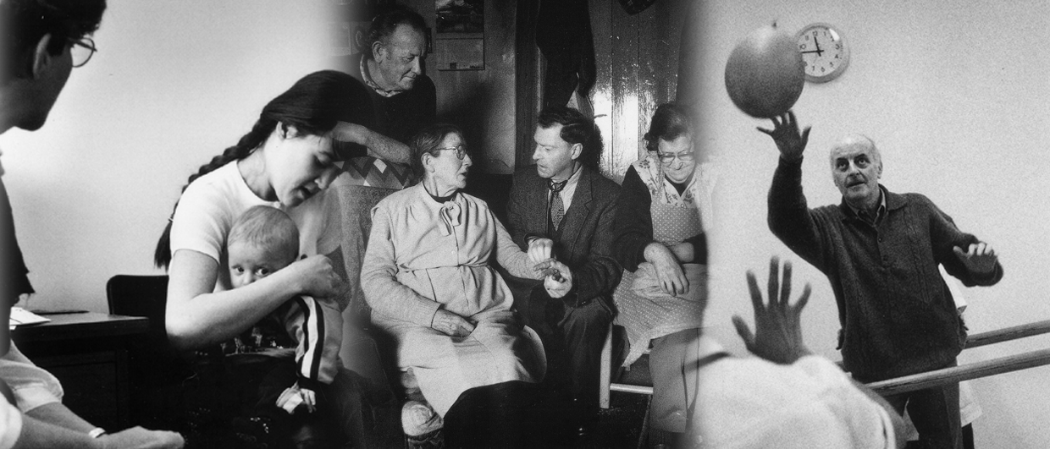
South West
Public Health
Training Programme

SOUTH WEST PUBLIC HEALTH
SCIENTIFIC CONFERENCE
2013

Thursday 7th February 2013

The Winter Gardens, Weston-super-Mare

call for abstracts

You are invited to submit abstracts for Oral and Poster presentation at the regional Public Health Scientific Conference to be held on Thursday 7th February 2013.

The aim of the conference is to showcase both service and university based public health research and evaluation from across the South West. This year there will be a specific focus on service based research and health service evaluation or audit.

However you are invited to submit abstracts from across the full range of public health and from all disciplines working in public health in the South West.

To help with the submission of abstracts, guidance and an example abstract are attached.

Abstracts should be sent to the conference organisers via beth.carpenter@bristol.nhs.uk and be received by Friday 26th October 2012.

If you would like to discuss the content of your abstract please contact one of the following members of the conference abstract committee:
Prof Yoav Ben-Shlomo Tel: 0117 928 7206
Professor in Clinical Epidemiology Email: Y.Ben-Shlomo@bristol.ac.uk

Prof Ken Stein Tel: 01392 726067
Professor of Public Health Email: Ken.Stein@exeter.ac.uk

SOUTH WEST PUBLIC HEALTH
SCIENTIFIC CONFERENCE
2013

Guidance for abstracts

Please complete the attached submission form and return it with a copy of your abstract to beth.carpenter@bristol.nhs.uk quoting Scientific Conference Abstract in the email subject line.
The final deadline for receipt is Friday 26th October 2012. Abstracts received after this date will not be considered.

Important information regarding abstract layout:

The abstract must be no longer than 300 words maximum (excluding title, authors and affiliations, keywords and references)
Text should be single line spaced with justified margins
Each abstract must use Word Arial font in size 11 point
Abstracts should be saved as a Word document using the author’s name as the file name
Abstracts should be presented in accordance with the following guidance:
The title of the abstract must be in bold. The first letter of each word of the title must be in upper sentence case.
Full details of all the authors must be provided. This should include name; role and organisation/affiliation
The name of the author that wishes to present at the conference must be underlined
The authors’ roles and organisations/affiliations should be written in italics
The aim of the abstract presentation must be clear
It is advised to use the following sub-headings where relevant and appropriate:
Aim
Background
Methodology
Results / Findings
Conclusions / Recommendations

Abstracts that fail to adhere to the required abstract layout as outlined above will be rejected. Abstracts will be reproduced on the conference website exactly as submitted, so please check abstracts carefully before submission.

Abstracts will be peer reviewed and presenting authors of successful abstracts will be notified by 12th November 2012.

Please note that acceptance of your abstract does not give you a delegate place at the conference and you will be required to register a place when registration opens in November.

Oral presentations will generally be allocated 12 minutes, followed by 3 minutes for discussion. Poster presentations will be provided with space for one board.

South West
Public Health
Training Programme

SOUTH WEST PUBLIC HEALTH
SCIENTIFIC CONFERENCE
2013

Thursday 7th February 2013

The Winter Gardens, Weston-super-Mare

abstract SUBMISSION FORM

Abstract Title

Presenting author (to whom all correspondence will be addressed)

Title (Prof/Dr/Mrs/Ms/Mr)
First Name
Last Name
Role / Job Title
Organisation / Affiliation
Address for correspondence
Postcode
Telephone
Email

Co-authors and Organisations / Affiliations

Please indicate the type of abstract submission you are making:

Oral presentation abstract
Poster presentation abstract
Abstract to be considered for both oral and poster presentation

Please return to beth.carpenter@bristol.nhs.uk by Friday 26th October 2012
quoting Scientific Conference Abstract in the email subject line
EXAMPLE ABSTRACT:

Systematic Review and Economic Evaluation of Lifestyle Interventions to Treat Overweight and Obesity in Avon Children

Hollingworth W; Hawkins J; Kipping R

Department of Social Medicine, University of Bristol, Bristol

Aim: To estimate the life-time cost-effectiveness of interventions to treat obesity in primary school aged children from an NHS perspective.

Background: Obesity in children is associated with a range of adverse health conditions. Obese children are more likely to be obese as adults and develop related diseases. It is a public health priority to prevent and treat obesity in children and adults, in order to reduce morbidity and premature mortality.

Methodology: Updated systematic review of costs and effects of child lifestyle interventions to treat obesity evaluated in randomised controlled trials (RCTs). Economic evaluation adapting the National Heart Forum economic model to predict NHS costs, life expectancy and incidence of obesity related disease. Cohorts of obese and overweight children were simulated using height and weight data, collected as part of the National Child Measurement Programme, for 4-5 and 10-11 year olds in the Avon area. The cohort was ‘aged’ by the model, developing weight related disease and incurring treatment costs based on projections from the Health Survey for England.

Results: Ten RCTs were identified; setting, intensity and delivery of interventions varied widely. The median effect of interventions was a -0.13 (range: 0.04 to -0.60) reduction in BMI-SDS at 12-months. Cost of intervention ranged from £108 to £2,400 per child. For obese children aged 10-11 a median estimate of effect size and cost (£400 per child) led to an increase in life expectancy of 0.19 years and an incremental life-time undiscounted cost saving of £110, though this saving did not emerge until nearly 60 years post-intervention. Discounted cost per life year gained was £13,589. Results were broadly similar for children aged 4-5 and when targeting both obese and overweight children.

Conclusions: Interventions to treat childhood obesity are potentially cost-effective, although the majority of cost-savings and health benefits will not appear until after the sixth decade of life.

