8G, The Leathermarket, Weston Street, London, SE1 3ER
0203 176 5380 www.trilliumsystems.net info@trilliumsystems.net
How to Guide

SharePoint Registrar processes
 | Attention: | Faculty of public Heath
 | Company: | Faculty of public Heath
 | Prepared By: | Antonio Ascione
 | Date: | 27 January 2015
 | Reference: | n/a
 | Version: | 1.0
Please Note:

All information contained in this document is copyright Trillium Systems Limited © 2015.
The information is intended for the recipient, British Association of Art Therapists, and their associated companies and agents. The intellectual property contained herein remains the property of Trillium Systems Limited and may not be used, applied, distributed, referenced, forwarded or adapted in any way without the written consent of Trillium Systems Limited.
Breach of this intellectual copyright may result in legal action.
All Trademarks are property of their respective owners. All rights reserved.

Registrar general menu

General overview Left Bar menu
The left bar menu shows 3separate sections (‘My Portfolio’, ‘Learning Outcome’ and ‘ARCP’) and a message displaying the role/roles associated to the user.
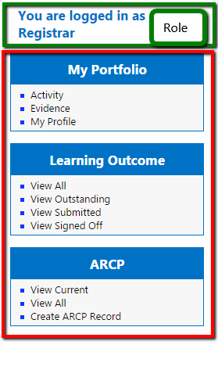

My Profile

Edit ‘My Profile’ information
- Go to My Profile -> My Profile and Click “My Profile”
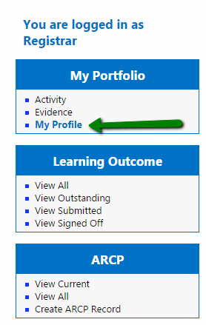
- The most of the fields of the form can be updated apart from the “First Name” and the “Last Name” fields and the “Region” field (if has already been set). All the fields that cannot be updated are greyed out.
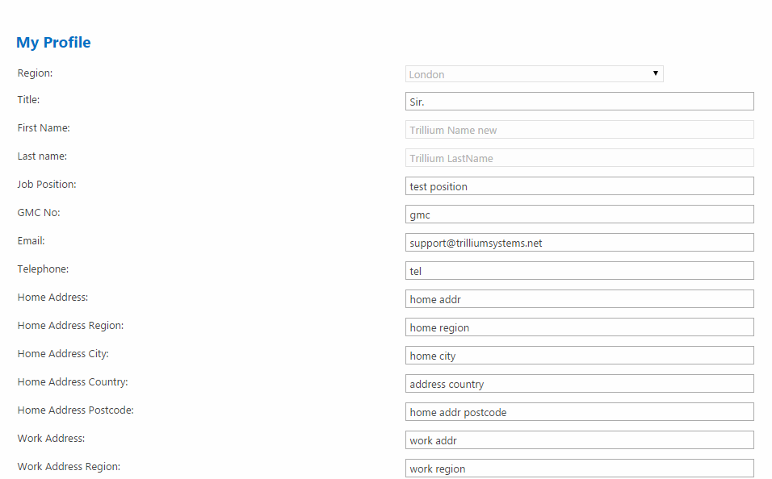

- Fill in the form with the information you want to update and Click “Update Profile”
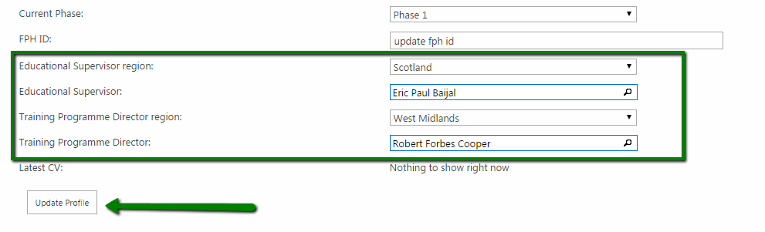

- Select an Educational Supervisor and a Training Programme Director by using the “Educational Supervisor Region” dropdown as filter or directly typing the supervisor name into the “Educational Supervisor” or “Training Programme Director” textboxes. The supervisor name, if exists will be prepopulated while typing.
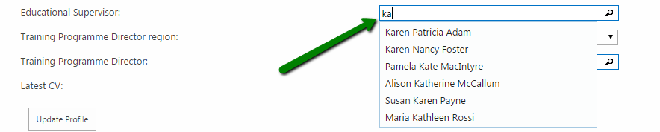
- If the no “Educational Supervisor” or “Training Programme Director” are set in the profile, the system does not allow to update the details showing an error message.

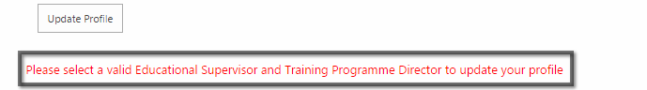
- In case you are uncertain about the supervisors but you want to update your personal information anyway Set as TPD and ES in the profile the user ‘’System SU” from typing “System SU” in the “Educational Supervisor” and “Training Programme Director” fields.
Once these fields are set this form can be updated at any time.
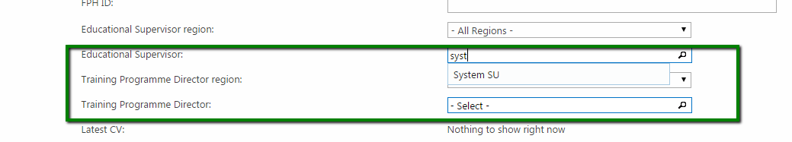

Evidence

View Evidence list
- Go to My Portfolio -> Evidence and Click “Evidence”

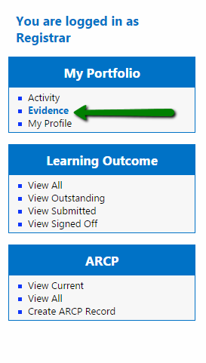
- The list shows all the Evidence inserted into the system by your user.
The “Search bar” allows the filtering of the results in the grid while the “Paging section” allows the navigation through the table by clicking one the page indexes at the bottom of the grid.
In addition to this, it is possible by clicking on any of the headers, to sort the items in the grid alphabetically or chronologically depending on the type of information of the column.
Please note that all the grids of this kind in the system have those types of functionality (filtering/sorting/paging)

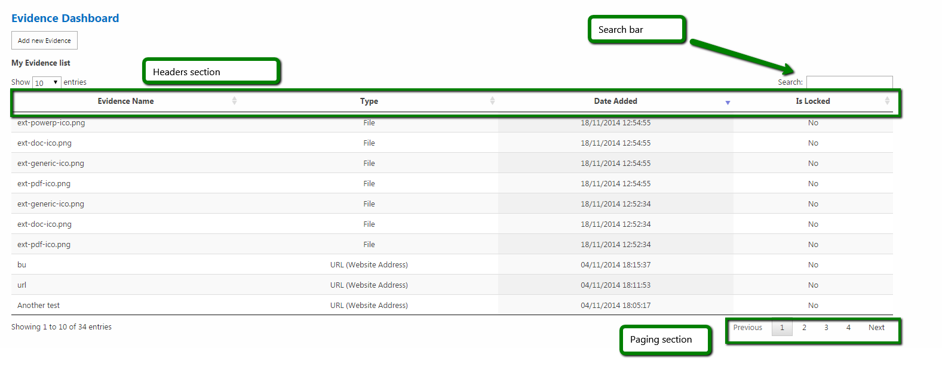

Upload Evidence file/files
- Follow the steps 1 and 2 described in the “View Evidence list” process to access the “Evidence Dashboard” page.
- Click “Add new Evidence”
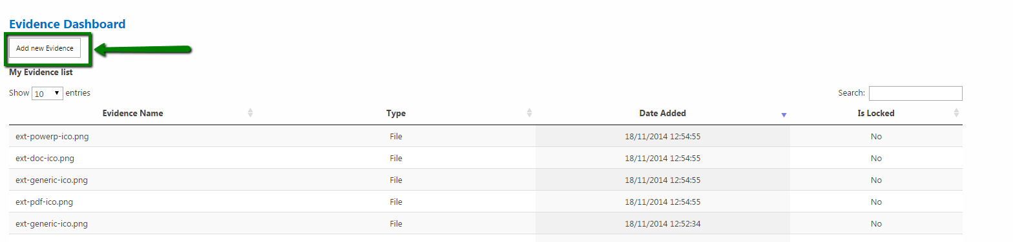
- Drag and drop a single or multiple files into the greyed area in the centre of the page or just Click on the grey box to select the files using the file explorer.
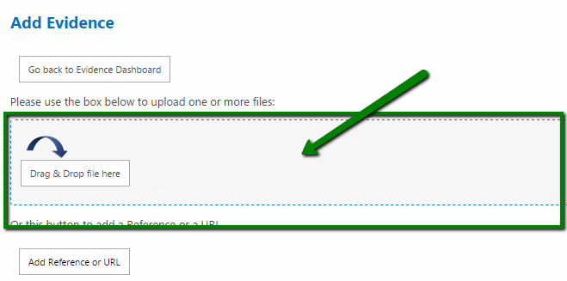

- Provide a short description for the files now shown in the grey area or eventually remove the files by using the “Remove” buttons on each file preview.
Click “Upload button” and wait until the process is complete.
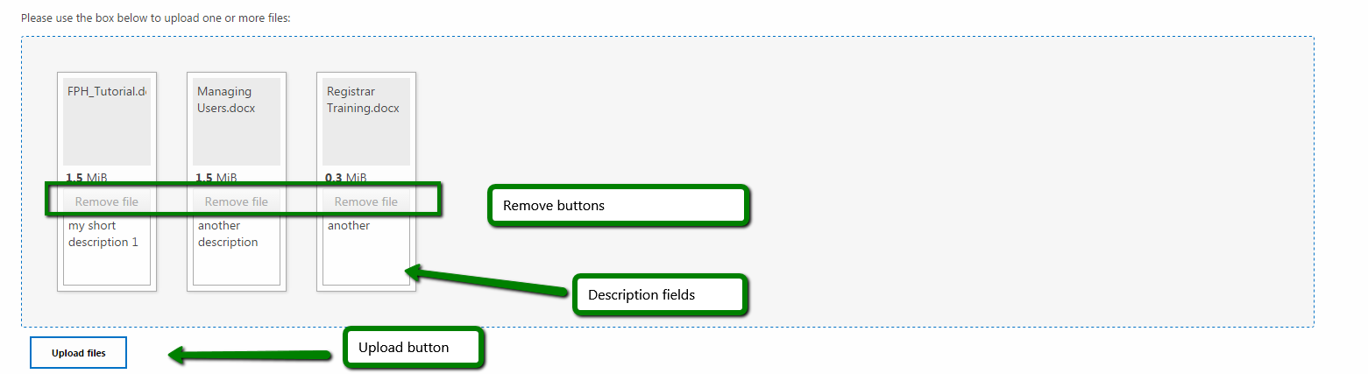

- If the process is successfully complete Click “Close” in the confirmation modal window generated by the process to be redirected to the “Evidence Dashboard”
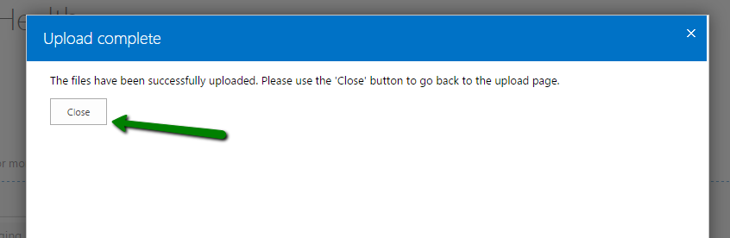

- The “Evidence Dashboard” is now showing the 3 uploaded files, now ready to be associated to activities.
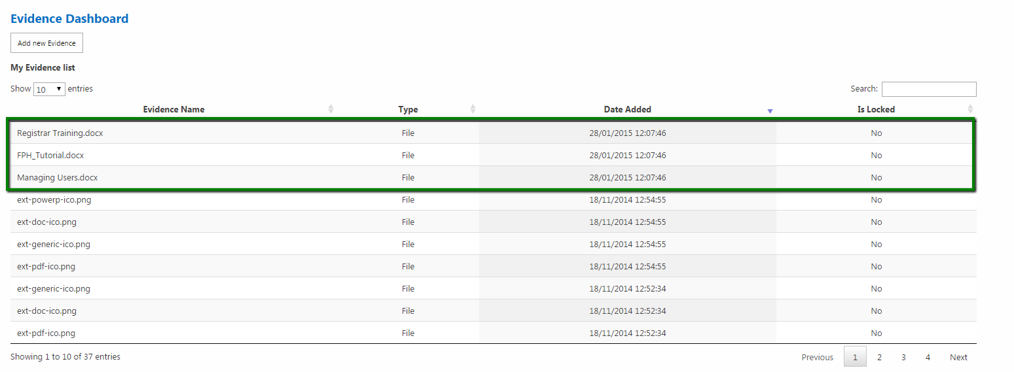

Add Evidence (Reference or URL)
- Follow the steps 1 to 3 (included) described in the “Upload Evidence file/files” process.
Click “Reference or URL”
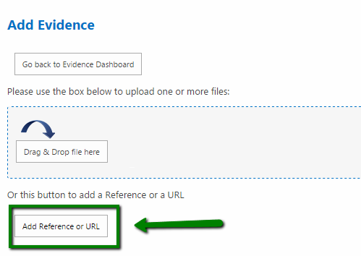
- Complete the form populating all the fields (all mandatory) and providing a valid URL (which must include the prefix http:// such as “http://www.google.com”)
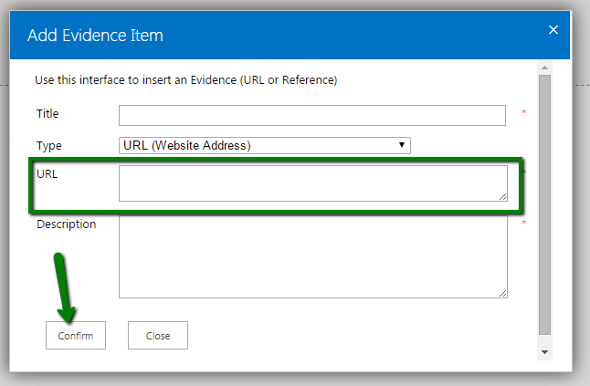

- In case the provided URL is not valid or one of the other fields is left blank the modal window shows this error shown at the bottom of the pop-up. In this case repopulate the form with valid data and resubmit by using the “Confirm” button.
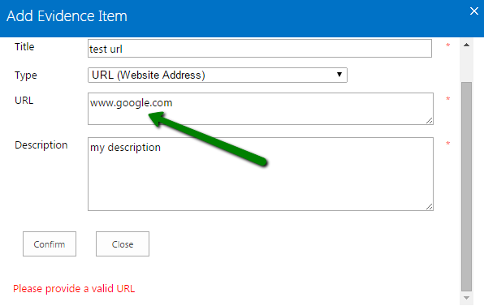
- To add an Evidence (Type: Reference). Just select the type “Reference” option in the “Type” dropdown. The form will not ask for a URL field in this case.

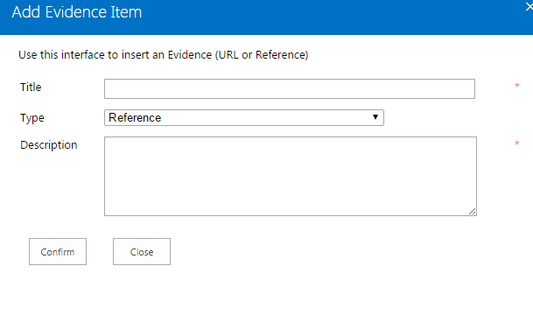

Delete an Evidence item
- Follow the steps 1 and 2 described in the “View Evidence list” process to access the “Evidence Dashboard” page.
- Click on the row related to the Evidence item you want to delete, then submenu related to the current item Click “Delete item”.
Please notice that if the Evidence is locked it is not possible to remove it from the system.
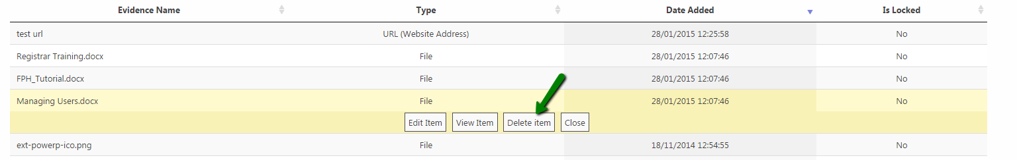

- In the modal window confirm the deletion by clicking “Delete”. Please note that as notified by the message in the window, the deletion process will also delete all the associations with activities and learning outcomes for the Evidence that is getting deleted
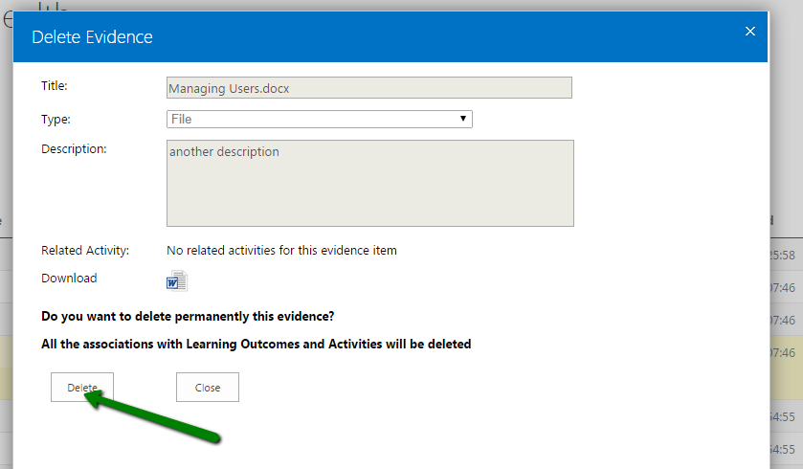

Edit Evidence details and overwrite the Evidence file
- Follow the steps 1 and 2 described in the “View Evidence list” process to access the “Evidence Dashboard” page.
- Click “Edit Item”. Please note that you can access to this functionality only for not “locked” Evidence.
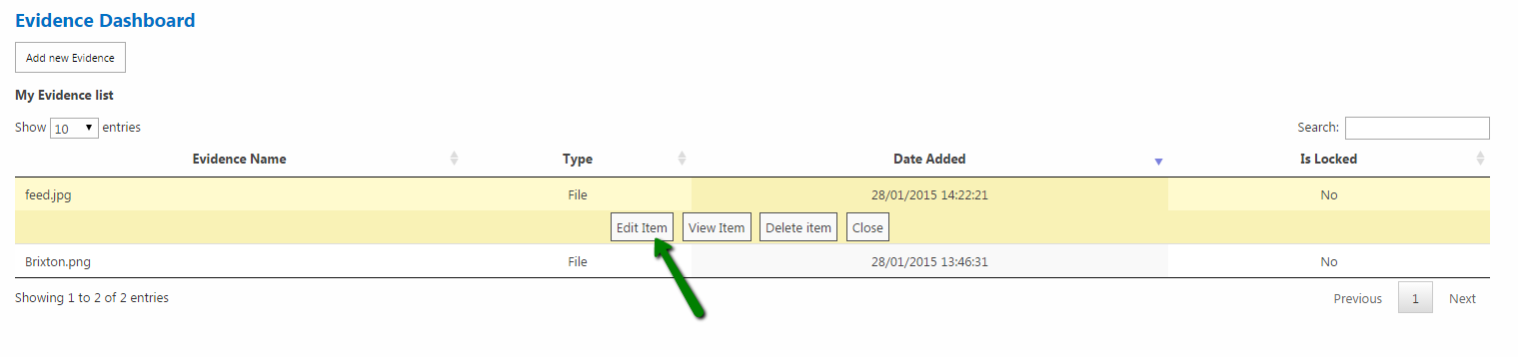
- To re-upload the file Click on the greyed area or Drag and Drop a single file into the area using the same approach used to insert an Evidence, then Click “Submit”

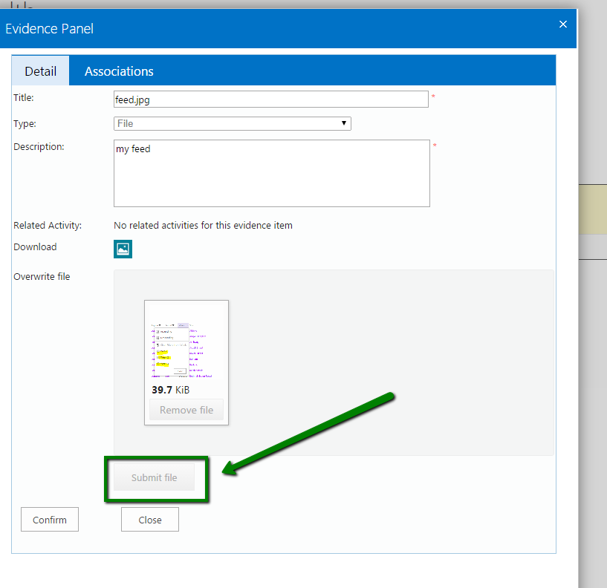
- If the process is successfully completed the page refreshes and allows you to eventually change the information such as the old title and the old description.
Update the “Title” and “Description” fields if needed and then Click “Confirm”

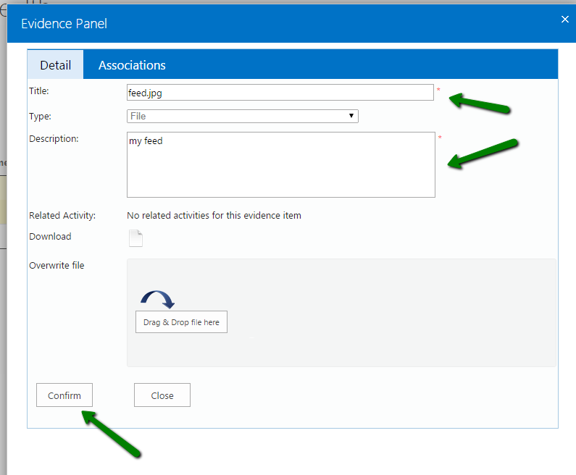

Create/Edit relations with Learning Outcomes
The prerequisite of this process is the existence of a relation between an activity and the evidence which is going to be associated to LO (shown in the Activity section of this document).
- Access the “Evidence Dashboard” as described in the previous processes and Click “Edit Item” (only available for not locked Evidence).

- Be sure the current Evidence is related at least to an activity by looking at the “Related activity” section
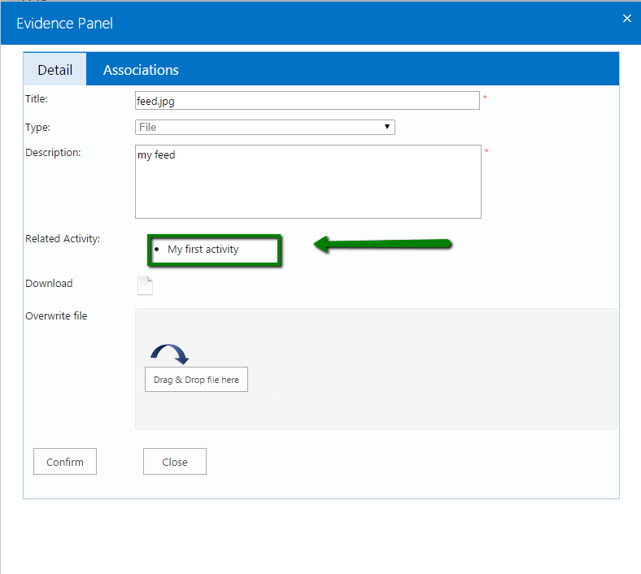

- Click the “Association tab” in the top of the modal window.

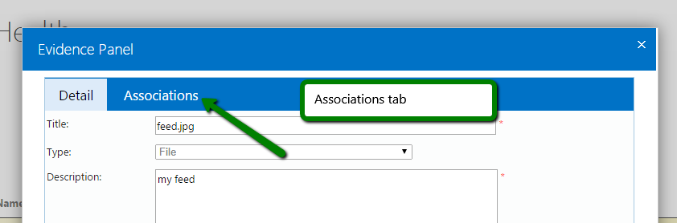

- In the “Related Activity” dropdown select the activity you want to take in consideration for the creation of the relations with the Learning Outcomes

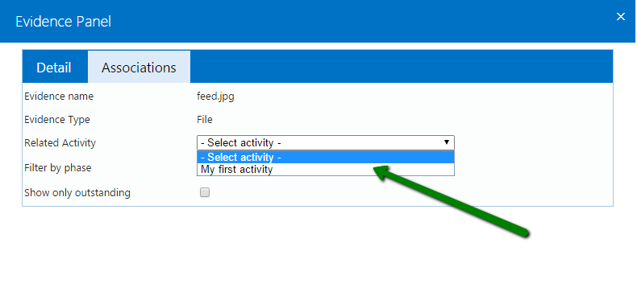
- The “Associations tab” now lists all the Learning Outcomes that can be linked to the association between the Evidence “feed.jpg” and the Activity “My first activity”.

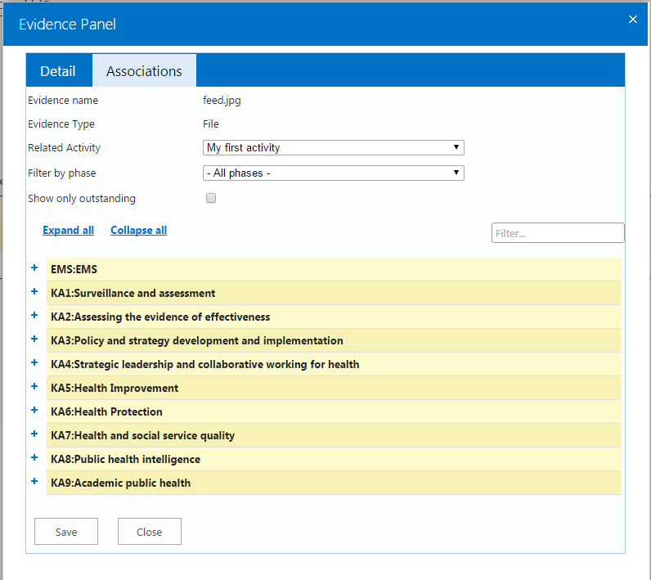
- Expand single or multiple categories of Learning Outcomes by using the “+” icons on the left side or expand all by using the “Expand all” link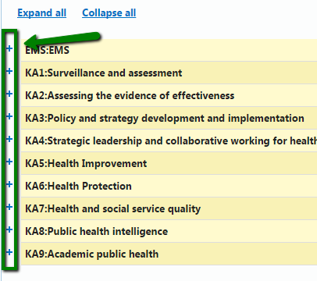

- Tick the checkboxes for the Learning outcomes you want to assign and provide a valid comment for the one ticked then Click “Save” at the bottom of the page. If the process is successfully completed you will be redirected back to the “Evidence Dashboard” page.

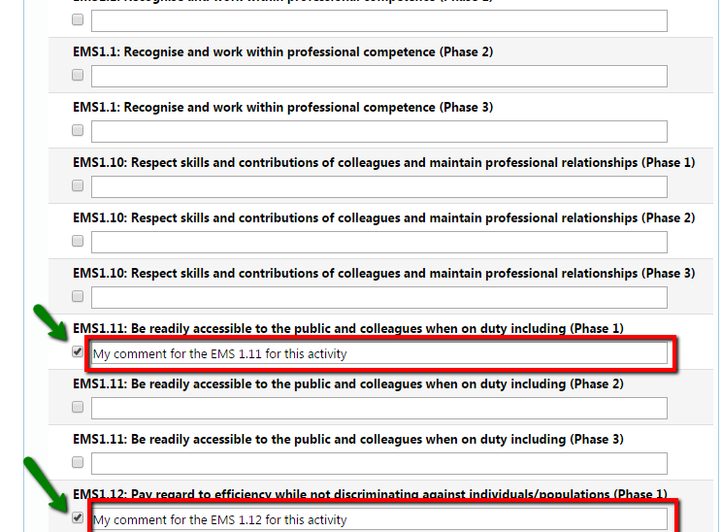

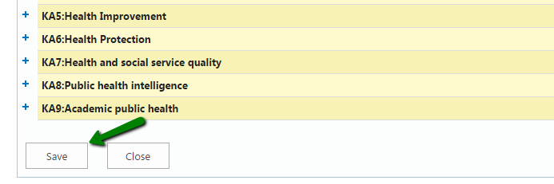
- By repeating all the steps in this process it is possible at any time to edit these relations, as well as update the description provided or remove an association by un-ticking the box related to a LO and then saving using the “Save” button
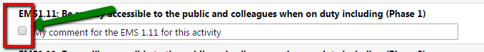

Filtering Learning outcomes
- The “Filter by phase” allows you to filter the Learning outcomes by phase. By setting “Phase 1” in the dropdown for instance the only Learning outcomes shown will be obviously the one related to the “Phase 1” excluding the one only included in “Phase 2” or “Phase 3”
- The “Show only outstanding” checkbox, if ticked, will show only the Learning outcomes which don’t have a related “Learning Outcome Sign-Off Sheet” (LOSOS) yet.
- The “Search box” allows you to filter the tree-view list

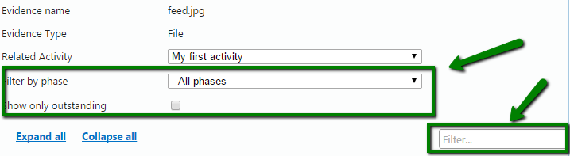

Activity

Access the “Activity General Dashboard”
- Go to My Portfolio -> Activity. Click “Activity”
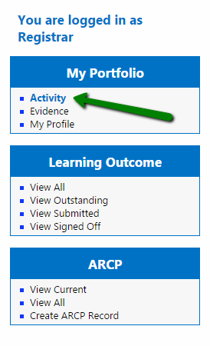

- The page shown summarises in a grid all the activities inserted by your user into the system with the all the functionalities of sorting/filtering/searching of the “Evidence General Dashboard”.
Please notice that some of the activities in the list could have “Migrated Evidence “as type. This special type of Activity has been generated in the new system to maintain consistency among the Learning outcomes’ relations with the old migrated system

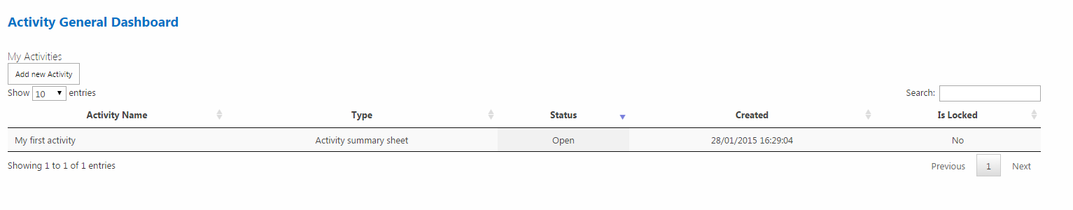

Add a new Activity
- Access the “Activity General Dashboard”. Click “Add new Activity”
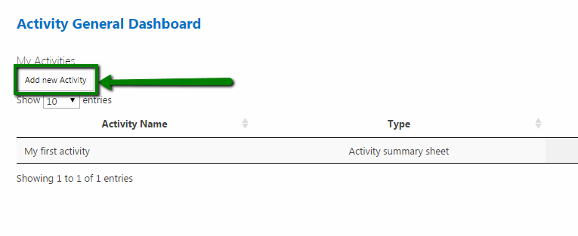

- Use the dropdown “Select region” to select the region of the “Activity Supervisor”. A dropdown will appear allowing you to select one of the supervisors related to that particular region

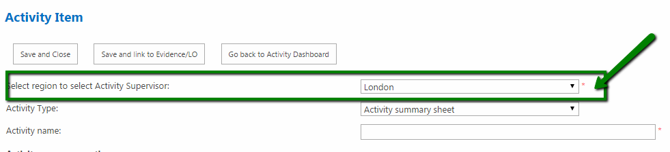
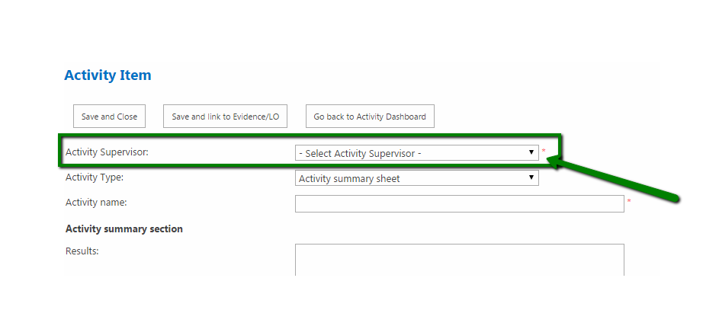
- Use the “Activity Type” dropdown to select the type of Activity you want to insert by choosing between the “Activity Summary sheet” and “Pre Planning Activity” options. The fields that can be populated vary according to the kind of Activity that is going to be created
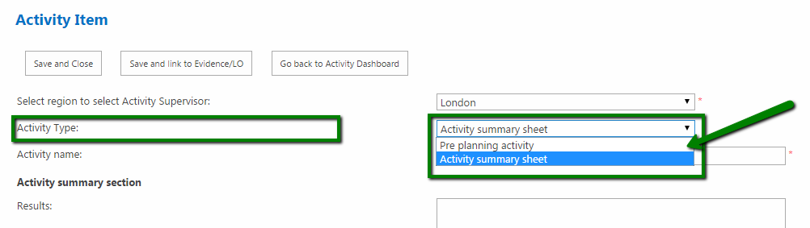

Pre planning activity form
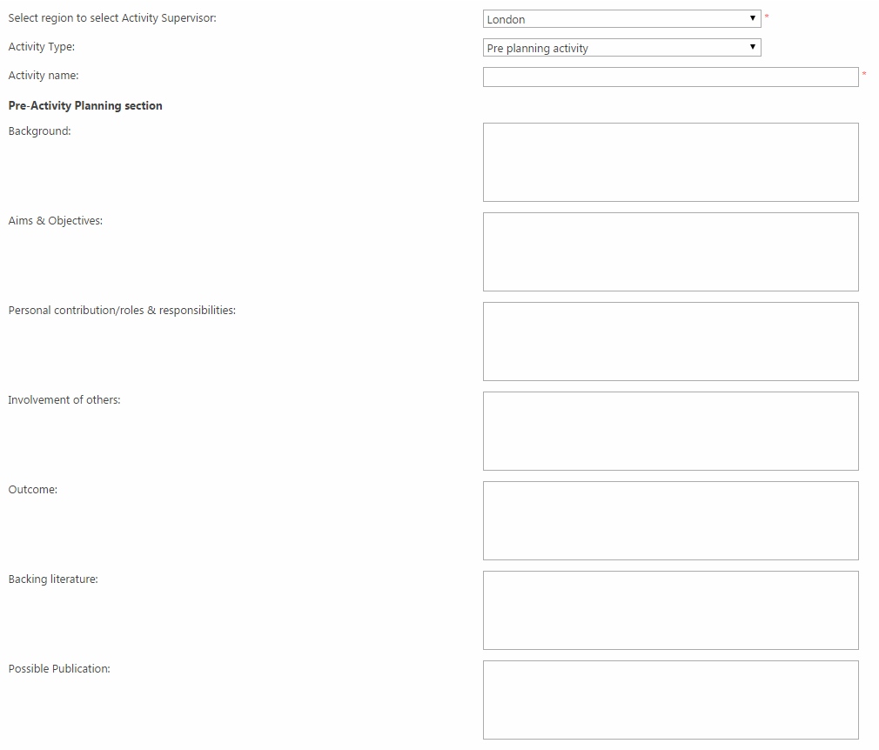
Activity summary sheet
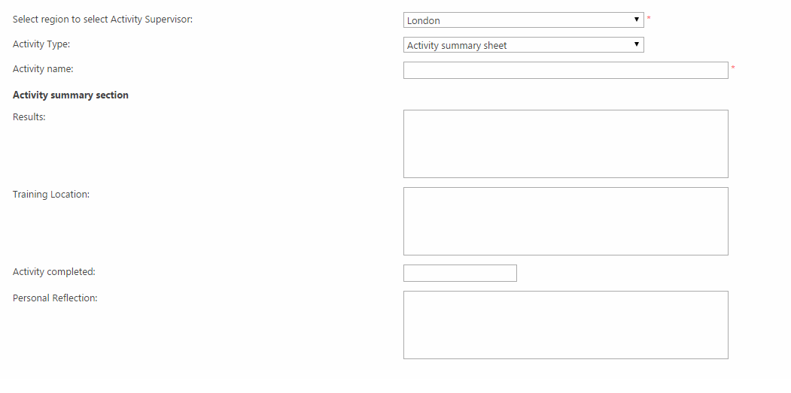

- Complete the form providing at least a valid activity name (not blank) and a valid activity supervisor (not blank) to be able to submit the form without error.
Click “Save and Close” or alternatively “Save and link to Evidence/LO” if you want to create relations to Evidence and Learning Outcomes at this stage.
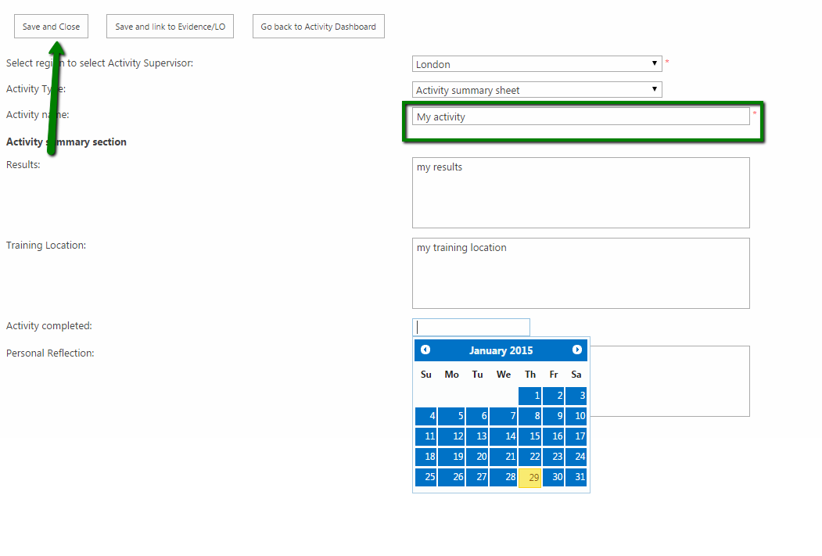

- The system now redirects you to the “Activity General Dashboard” where you can notice the activity just inserted and where you can eventually view, edit, delete or submit the activity by clicking on the related row in the grid
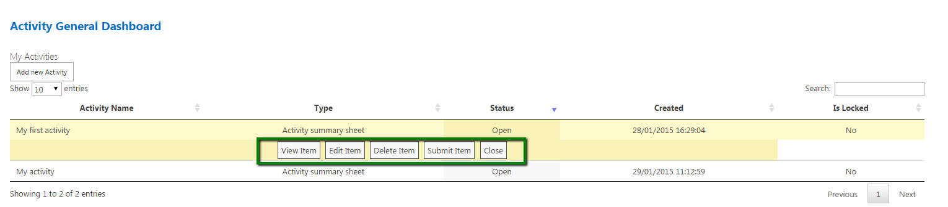

Create/Edit relations with Evidence and Learning Outcomes
- Go to the “Activity General Dashboard”. Click on the row in the grid of the activity you want to create/edit relations (only not “locked” activities allow you to edit their relations). Click “Edit item”.

- Click “Save and Link to Evidence/LO”
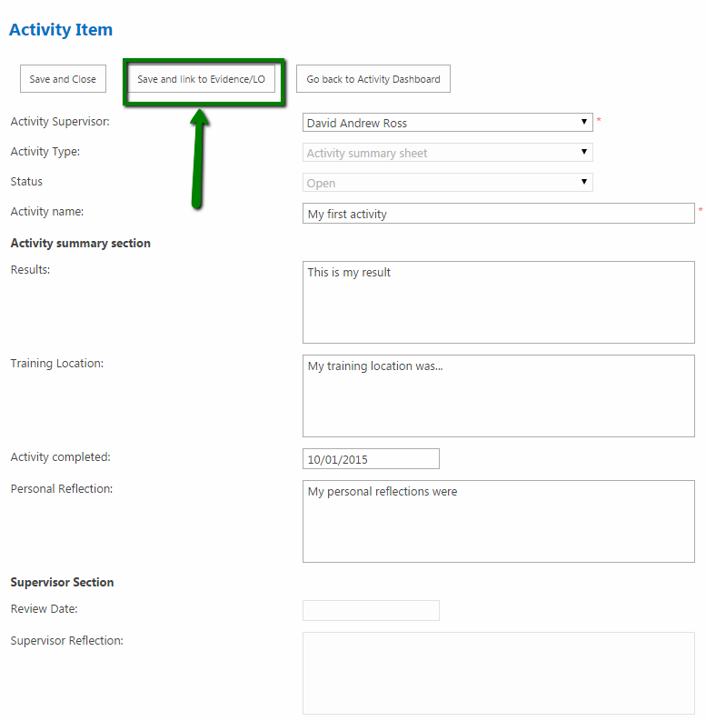

- The “Activity relations page” now shows in the upper part a list of Evidence (if any) and underneath the Evidence grid it shows a list of Learning Outcomes grouped by category in the same tree view list described in the “Create/Edit relations with Learning Outcomes” process in the Evidence section of this document.
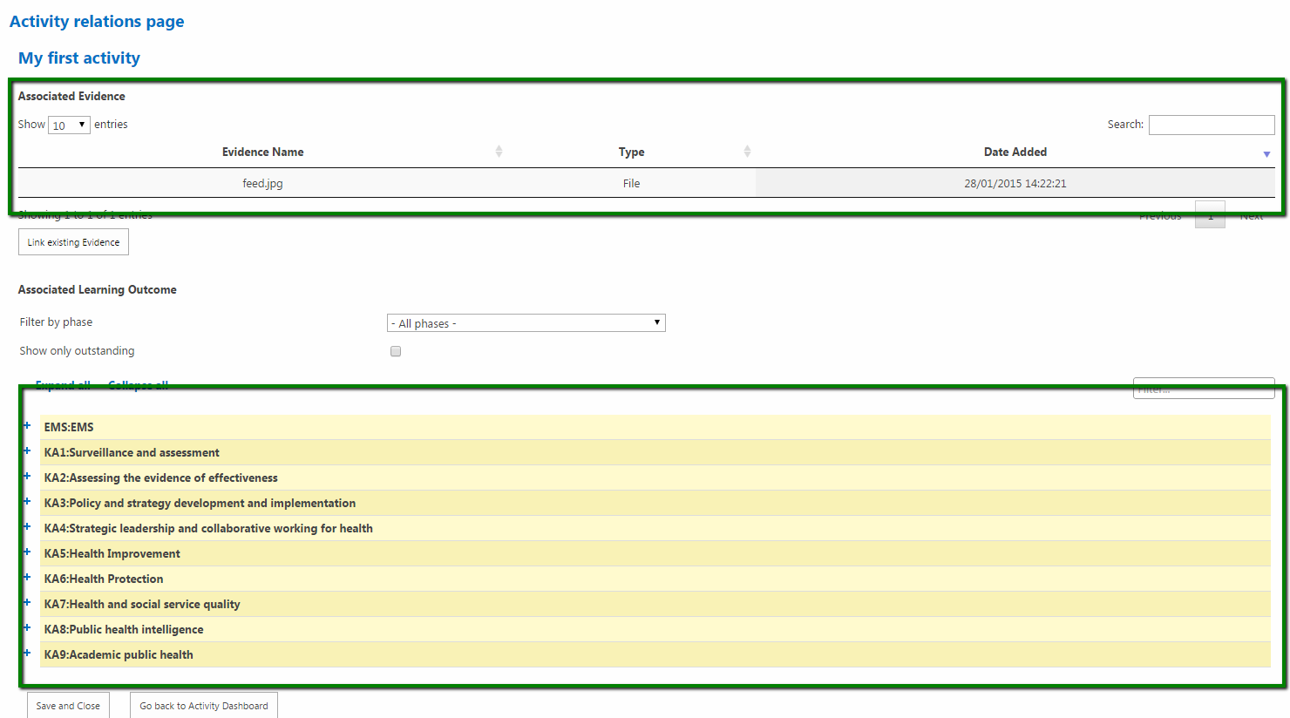

- Click “Link existing Evidence”
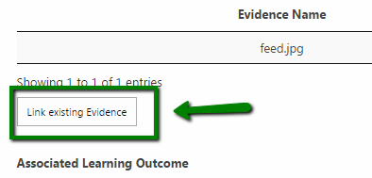

- In the modal window the evidence included in the left box lists all the available evidence to eventually associate to the Activity while the box on the right shows all the Evidence currently associated to the Activity.

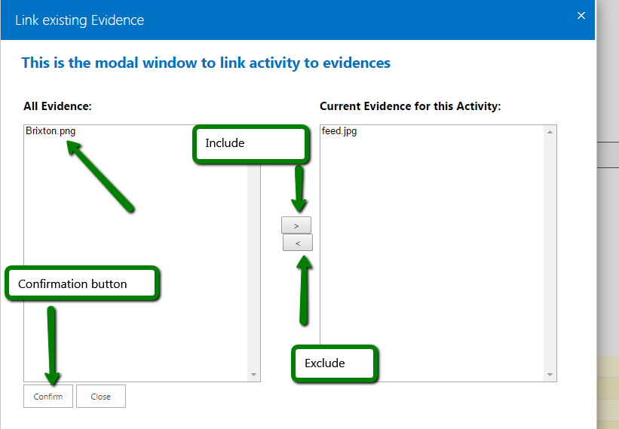

- To associate a not already associated Evidence to the current Activity Click on the name of the Evidence and then Click “>”. The Evidence will move from the left to the right box.
The same process can be used to remove a relation to an Evidence by selecting one or more Evidence in the right box (“Current Evidence for this Activity”) and using the “Exclude” button to move it to the left box.
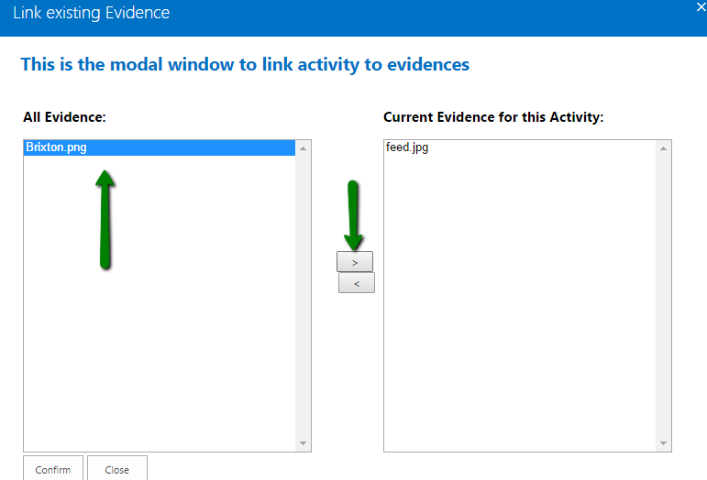

- Click “Confirm” 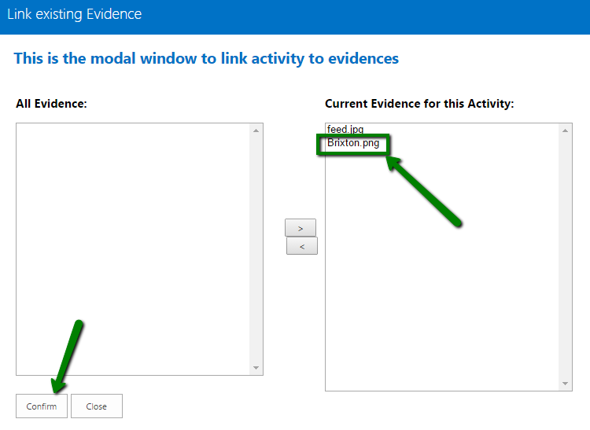

- The Evidence has now been associated.

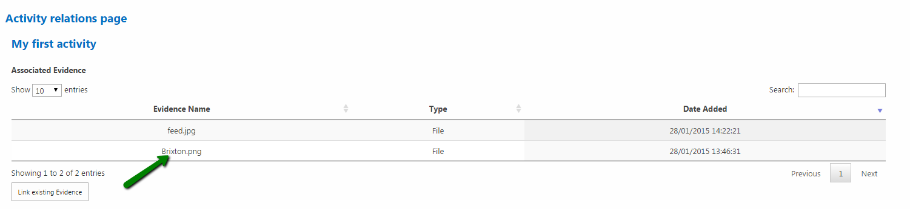

It is very important to understand that a very important feature of the system is the inheritance of relations. It means that all the previous relations with learning outcomes via other activities for the Evidence just associated become part of the relations for the current activity.

To edit or remove the existing relations, imported with the Evidence, just select or edit the Learning Outcomes in the lower part of the page as described in the “Create/Edit relations with Learning Outcomes” process in the Evidence section of this document.

Submit an Activity
- In the “Activity General Dashboard” Click the row related to the specific Activity you want to submit to the Activity Supervisor
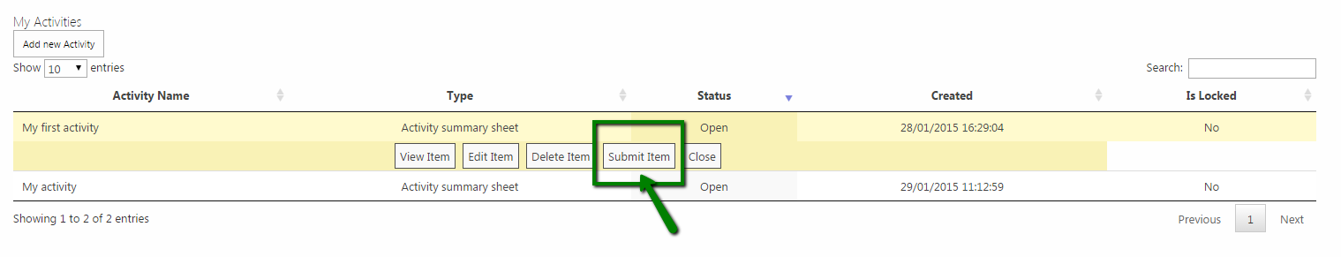
- Confirm the submission by clicking “Submit” in the modal window that is shown. As displayed in the window, all the associations with evidence and Learning Outcomes become locked (no possibility to associate more Evidence to the Activity) as well as all the related Evidence (no possibility to edit the single Evidence item if locked) and the Activity (no possibility to edit the Activity fields).
Once submitted, the Activity becomes reviewable by the “Activity Supervisor” related to it.
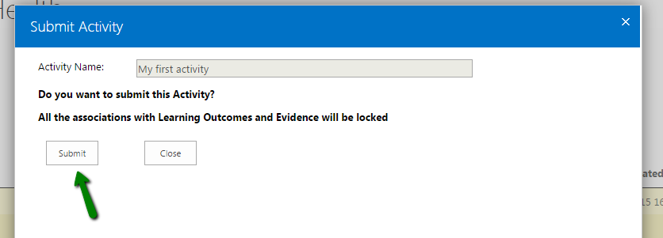

Learning Outcome

The “Learning Outcome” section in the left bar menu has 4 different links:
- View All
- View Outstanding
- View Submitted
- View Signed-Off
No matter which link button is clicked, the page where you will be redirected will be the “Learning Outcome Dashboard”
The difference in the result page consist on the kind of filtering applied to the results.
View All
Shows all the Learning Outcomes grouped in categories including the ones which LOSOS hasn’t been submitted yet.
View Outstanding
Shows only the Learning Outcomes which have a related LOSOS in “Under review” status
View Submitted
Shows only the Learning Outcomes which have a related LOSOS in “In Progress” status

View Signed-Off
Shows only the Learning Outcomes which have a related LOSOS in “Approved” status
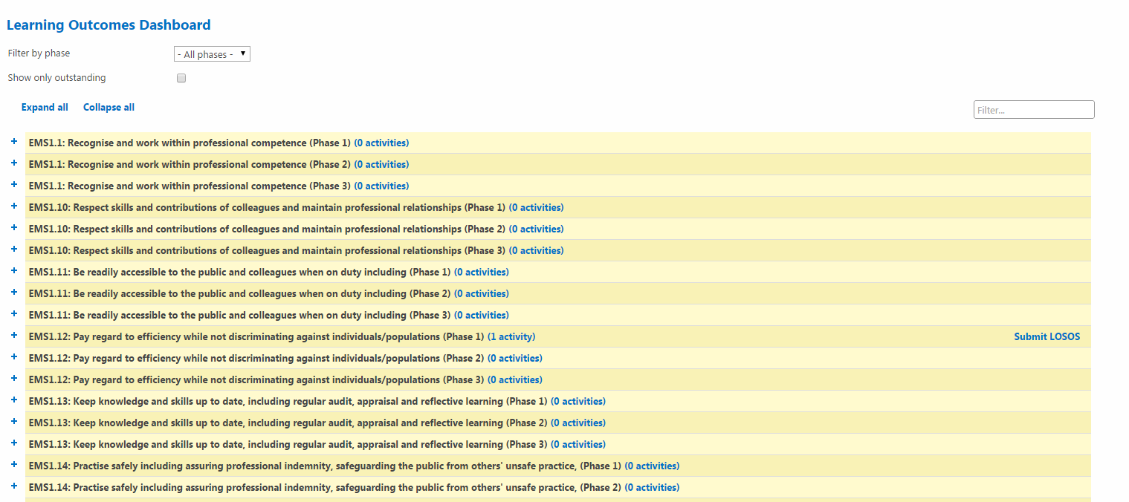
In the top area the filtering section allow you to filter the Learning Outcomes in the same way as describes in the “Filtering Learning outcomes” process

Learning Outcome Sign-off Sheet (LOSOS)

Submit a LOSOS
- Go to the “Learning Outcome Dashboard” as shown in the previous section by clicking “View All” or “View Outstanding” in the “Learning Outcome” section.
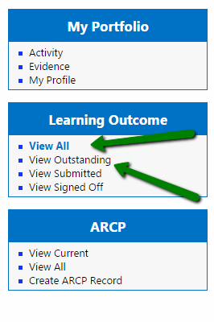
- The LOSOS that can be submitted are the ones related to Learning Outcomes with at least one associated Activity. You can check this by looking at the activities counted on the right side of the learning outcome title and expanding a specific node of the tree-view list to show the activities related to the Lo and the evidence related to each activity.

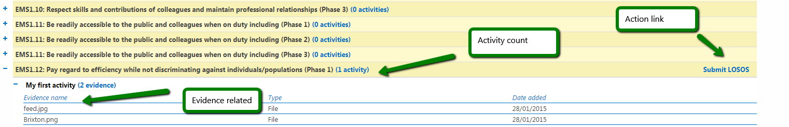

- Click “Submit LOSOS” being sure to have created in advance an ARCP item (explained in the next “ARCP” section of this document) and that the phase is set in your “My Profile” section.
Error on submission
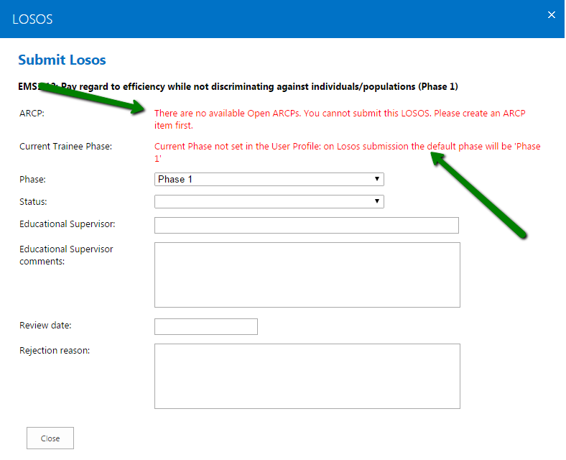

Phase and ARCP correctly set
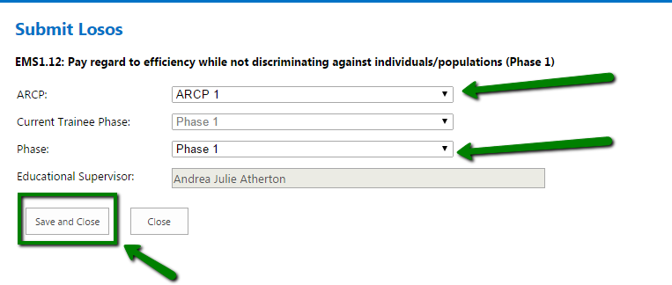

- Select one of the ARCP items option in the “ARCP” dropdown and the submission phase in the “Phase” dropdown (for Learning Outcomes that spans across multiple phases this dropdown shows multiple options). Click “Save and Close”.
The submitted LOSOS will be now viewable by clicking “View Submitted LOSOS” that now appears in the dashboard for that specific Learning Outcome.
Please note that the submission of a LOSOS for a Learning Outcome locks in cascade all the related activities and all the evidence related to each activity

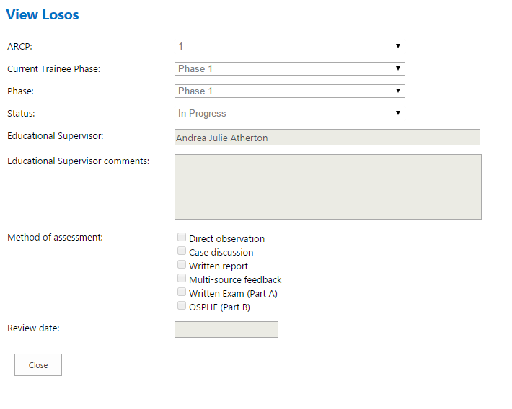

View Approved LOSOS
- The fastest way to view an approved LOSOS is to access the “Learning Outcomes Dashboard” via “Via Signed Off” link.
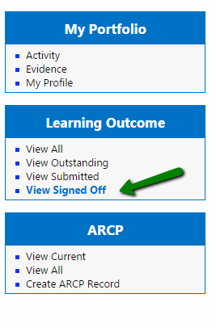
- Click “View submitted LOSOS”
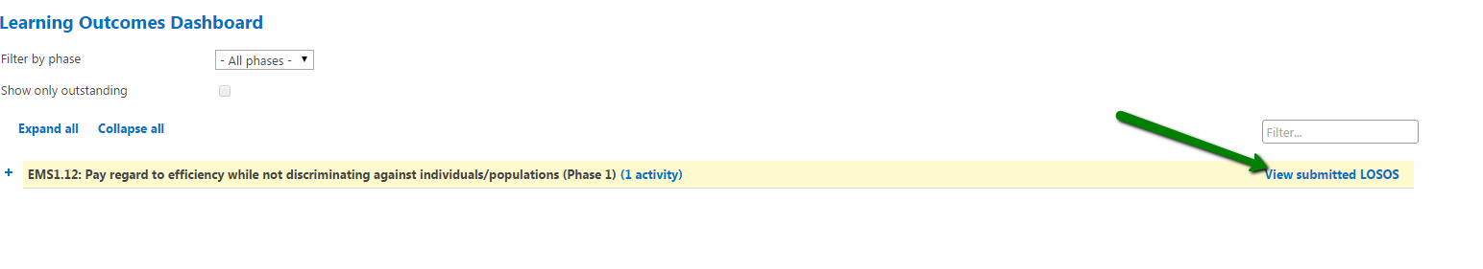

- View the LOSOS form (read-only fields) with the fields populated by the Educational Supervisor
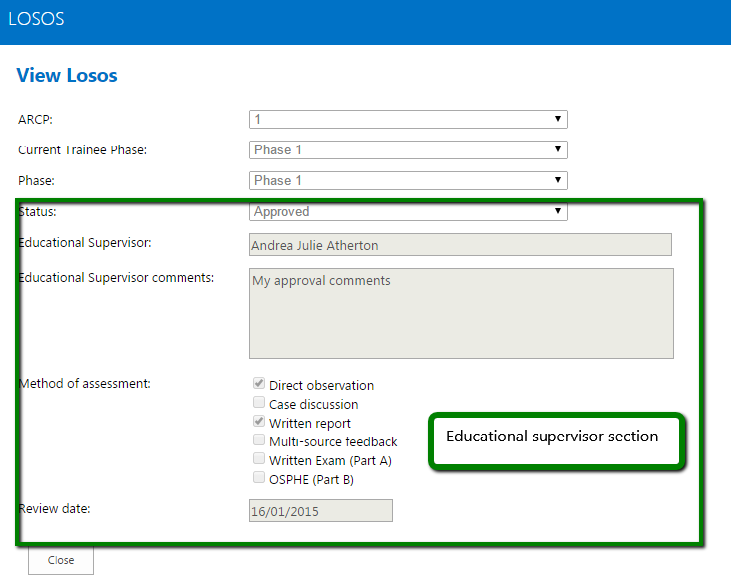

ARCP

Create an ARCP record
- Go to “ARCP”-> “Create ARCP Record”. Click “Create ARCP Record”.

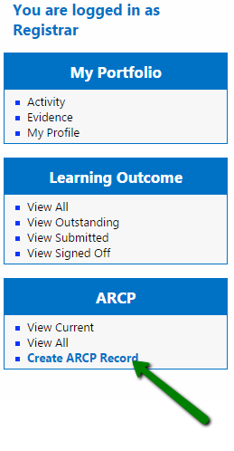
- Complete the form (at least the mandatory fields). Click “Save and Close”
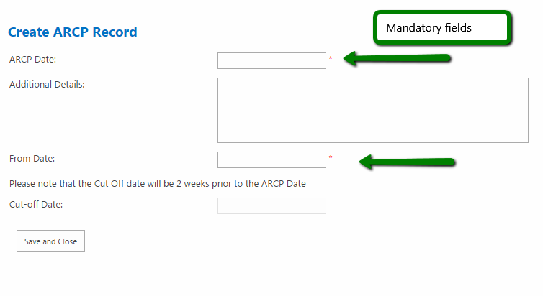

Access the ARCP General Dashboard
- Go to ARCP-> “View All”. Click “View All”
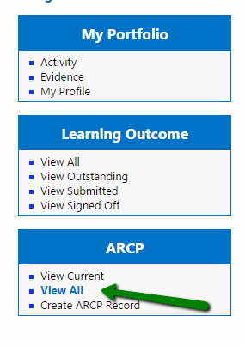

- The grid in the “ARCP General Dashboard” page will show all the “ARCP record” items giving the possibility to click each row showing a sub-menu where it is possible to select the “View Item” button to be redirected to the particular item detail page.

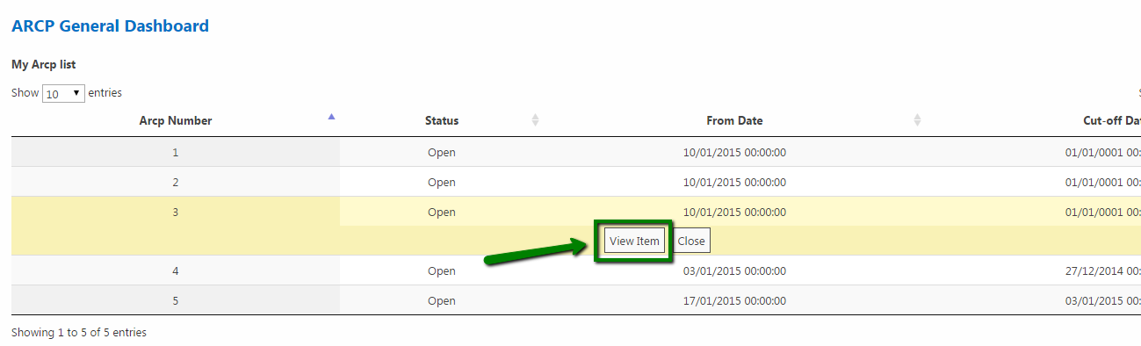

Access to an Existing ARCP record item
- Go to the “ARCP General Dashboard” then Click “View item” or Click “View Current “in the “ARCP” section in the left bar menu to be redirected to the ARCP item page.
This page contains:
- the “Details” section of the ARCP (“ARCP Date”, “Additional details”, “From date”, “Cut-off date” and “Status” fields)
- the “Associated reports” section where you can Submit/Finalise/Update/View reports (ESR, ASR and LAF)
- the “Personal documents” section where you can upload forms (Form 4 and Form R) and CVs in forms of files
- the “Associated Learning Outcomes” section with the usual tree-view list of LO-Activity-Evidence with the possibility to view the particular LOSOS associated by clicking the “View submitted LOSOS” link

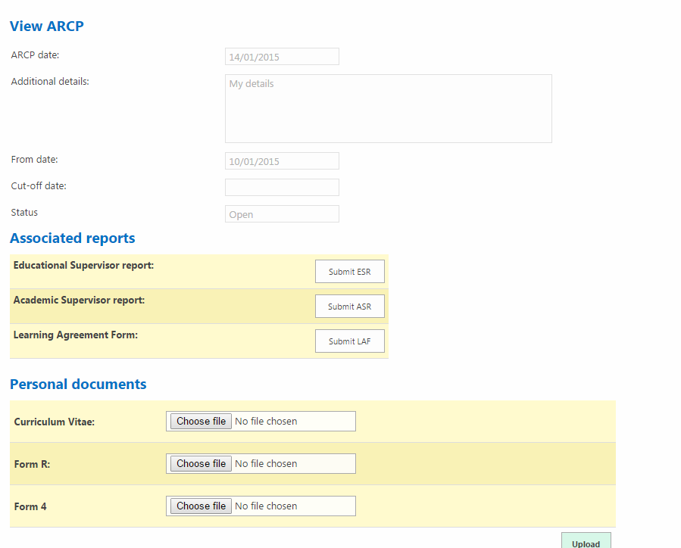

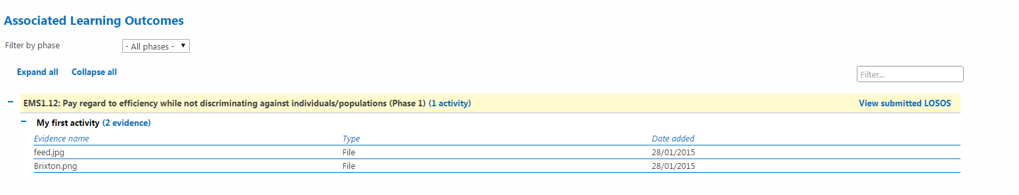

Upload personal documents
- Go to “View ARCP” items as shown in the “Access to an Existing ARCP record item” process.
Use the “Choose file” buttons to select the files you want to upload
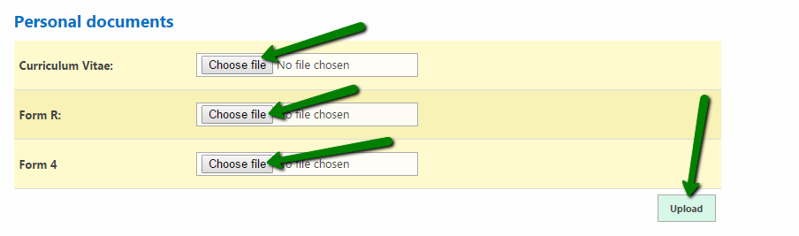

- When at least one of the 3 files has been selected Click “Upload”
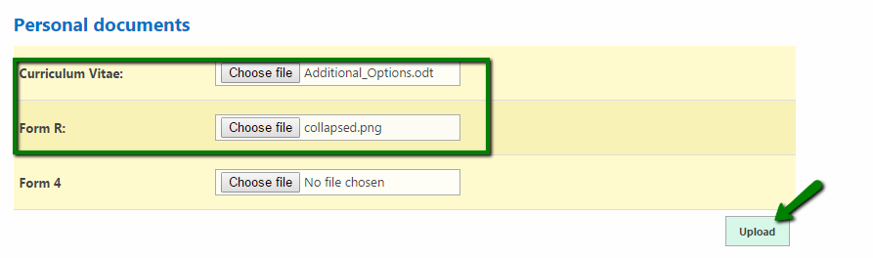

- When the process is complete you will be able to see the clickable name of the uploaded file/files on the right of the “Choose file” button.
If needed the “Remove” button allows you to remove the file and by clicking on the filename you are able to download the file on your local computer
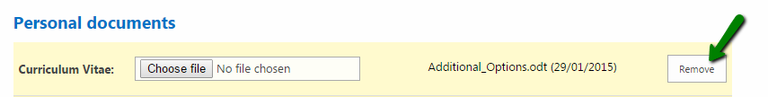
- If you want to upload another version of any of the documents by keeping the previous one just upload another file without removing the old one. You will be able to view all the versions of the file ordered chronologically with a date on the title
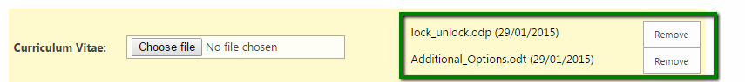

- In the particular case of the “Curriculum vitae” file if you Go to the “My Profile” you will find the latest version of your uploaded CV at the bottom of the page

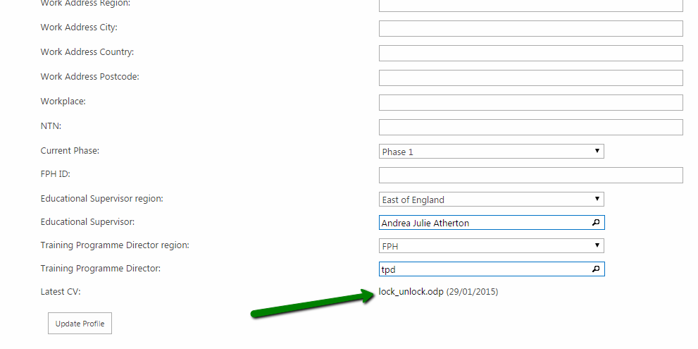

Educational Supervisor Report

Initiate Educational Supervisor Report (ESR)
- Go to the “View ARCP” item page as described in the “Access to an Existing ARCP record item” process. If no ESR has been already initiated by an Educational Supervisor the button shown in the “Associated Supervisor report” section will be “Submit ESR”.
Click “Submit ESR”

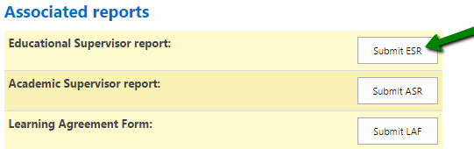

- Complete all the fields the form (the “Educational supervisor” field is not editable and is set to the current one set in the “My Profile” section and to be changed it needs to be updated from there). Click “Submit ESR”

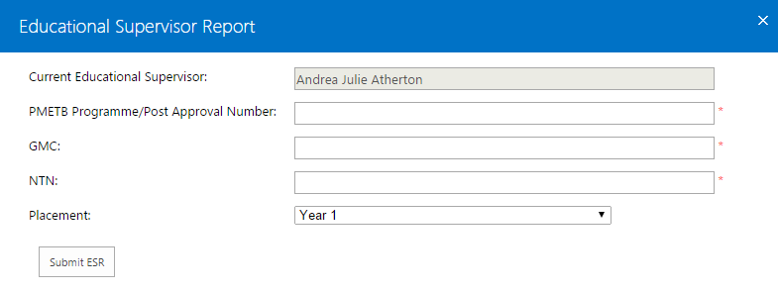

- If the process is successfully complete the “Associated Reports” section will show the “View ESR” button instead. Click “View ESR”.

- The ESR Report form is in read only now and shows an “Under Review” status. The related Educational Supervisor can now on his side approve or reject the report.

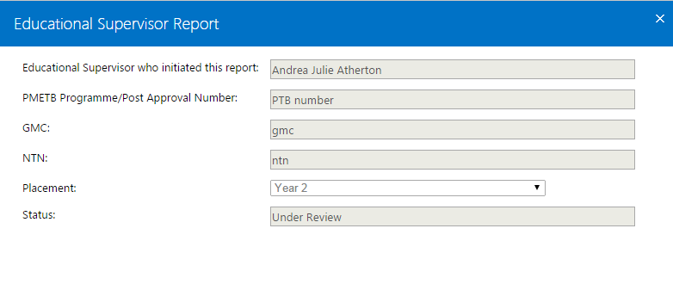

Finalise ESR
- In case the Educational supervisor has initiated or rejected the ESR, go to “Associated report section” and Click “Finalise ESR”
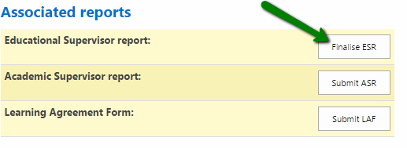
- Complete the form with valid data, then Click “Submit” to re-submit the ESR to the Educational Supervisor
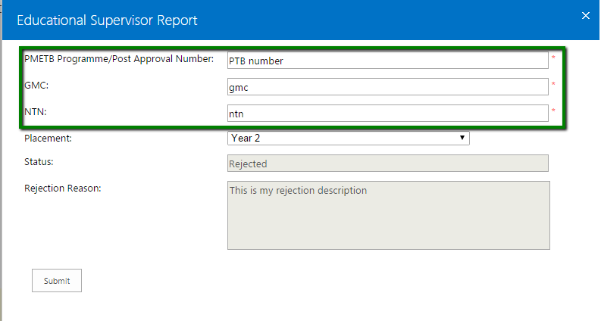

View Approved ESR
- In case of approved ESR the form is only viewable in read-only mode. Go to the “Associated reports” section then Click “View ESR”
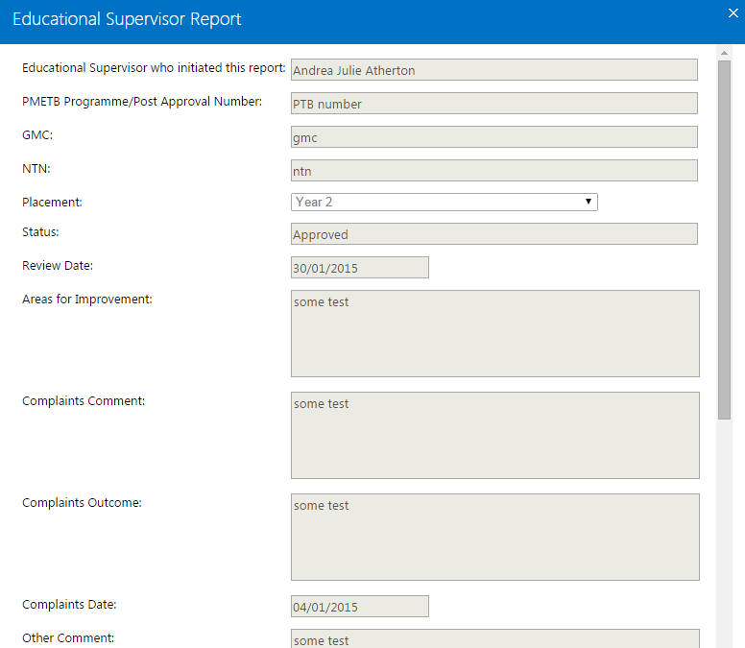

Academic Supervisor Report (ASR)

Submit Academic Supervisor Report (ASR)
- Go to the “View ARCP” item page as described in the “Access to an Existing ARCP record item” process. If the report has not been already initiated Click “Submit ASR”

- Select the region of the Academic Supervisor you want to associate to the report, then Select the Academic Supervisor in the dropdown that appears after the selection of the region. Complete the form then Click “Submit ASR”
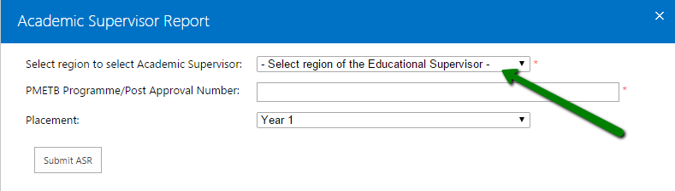

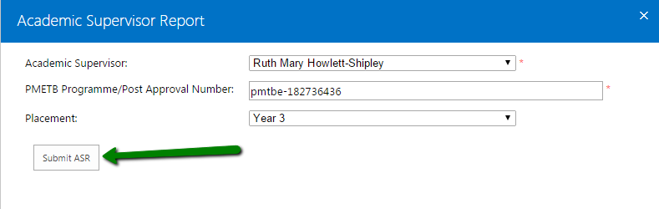

- The ASR has now been submitted (it is in “Under Review” status) to the supervisor and can be accessed in “view mode”

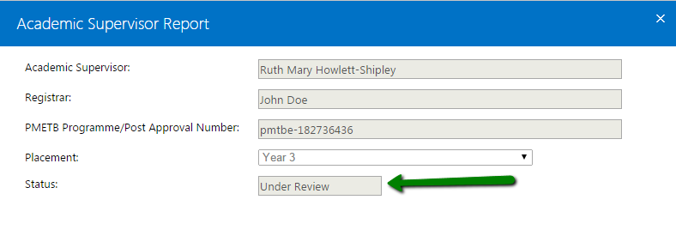

Update ASR if Rejected
- If the ASR is rejected by the Academic supervisor the button shown in the “Associated reports” section of the ARCP item is “Update ASR”. Click “Update ASR”

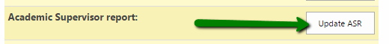

- Update the fields in the form eventually changing the Academic Supervisor then Click “Update ASR” at the bottom of the page

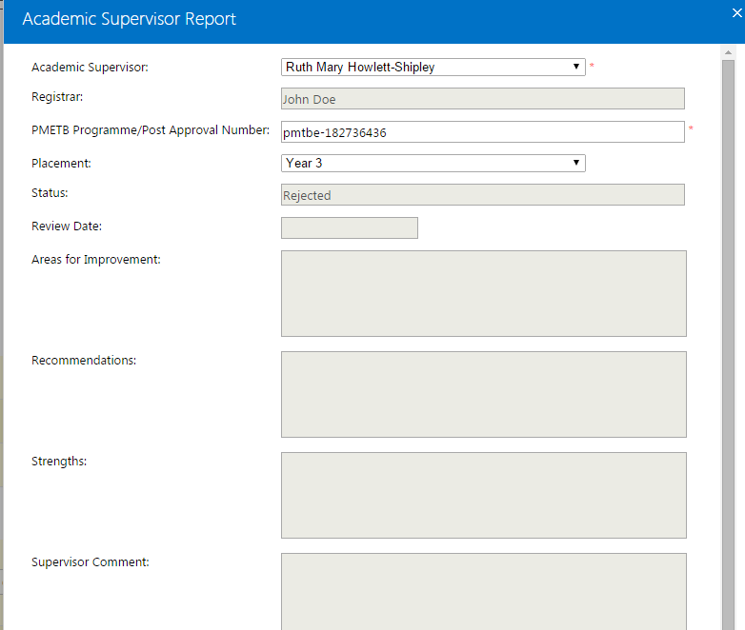

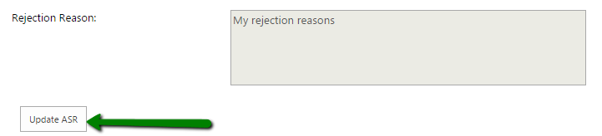

- The ASR has now been re-submitted and is viewable in view mode (it is in “Under review” status)
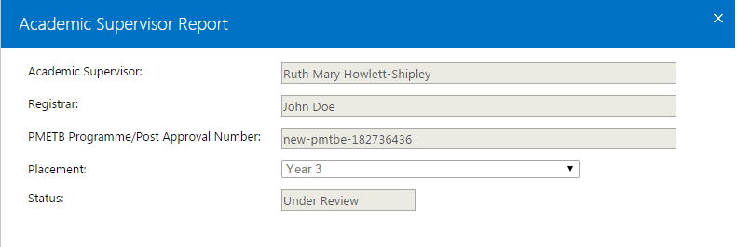

View Approved ASR
- In case of approved ASR the form is only viewable in read-only mode. Go to the “Associated reports” section then Click “View ASR”

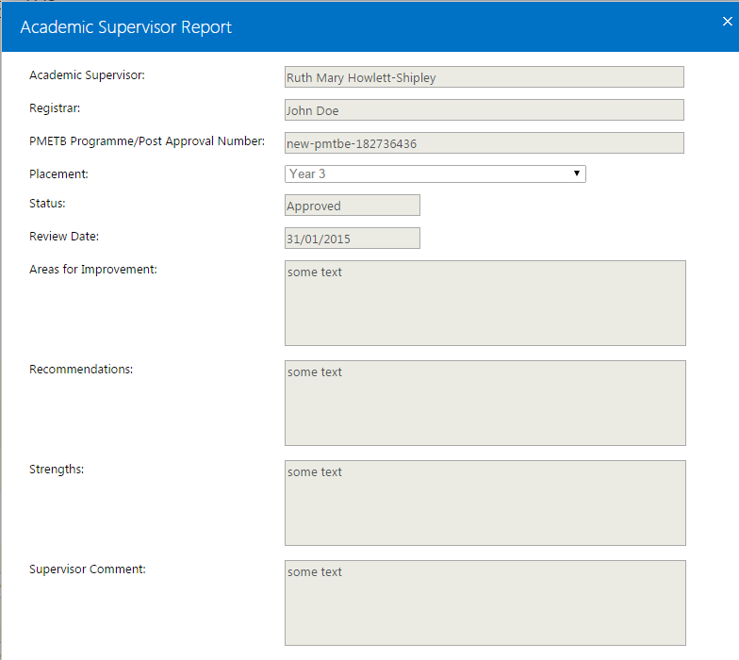

Learning Agreement Form (LAF)

Submit Academic Supervisor Report (LAF)

- Go to the “View ARCP” item page as described in the “Access to an Existing ARCP record item” process. If the report has not been already initiated Click “Submit LAF”
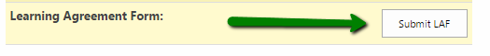

This report needs to be approved by two assessors (the Educational Supervisor and the Training Programme Director) and in case one of these two actors rejects the form, it is sent back for update.

- Complete all the fields in the form then Click “Submit LAF” at the bottom of the page (the ES and TPD are set as the ones in your “My Profile” section and cannot be updated on this form)
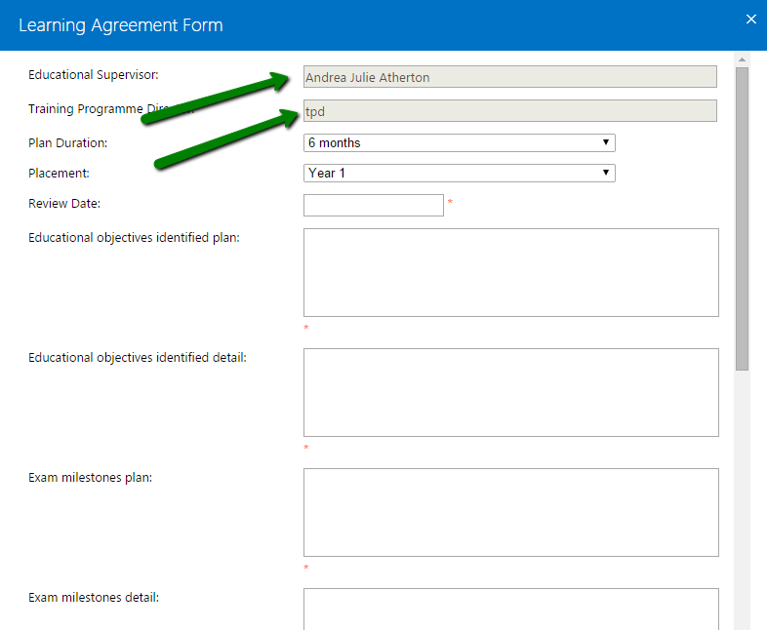

Update a LAF (if rejected)
- If the LAF is rejected by the Academic supervisor the button shown in the “Associated reports” section of the ARCP item is “Update LAF”. Click “Update LAF”

- Complete the fields in the form and Click “Update LAF” at the bottom of the page. You can find the reasons of the rejection in the field “Rejection Reason” placed just before the button.
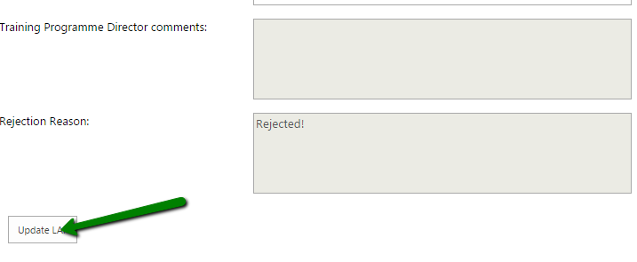

View Approved LAF
- In case of approved LAF (by both of the assessors) the form is only viewable in read-only mode. Go to the “Associated reports” section then Click “View LAF”

